COMSATS University Islamabad (CUI)

**Project Proposal**

**for BreathEX** Version 1.0

***By***

**Ahmed Kamran CIIT/SP20-BSE-004/ISB**

**Daniyal Hassan CIIT/SP20-BSE-025/ISB**

***Supervisor***

## Mam Sadia Maqbool

***Bachelor of Science in Computer Science (2020-2024)***

## Table of Contents

**Contents**

Abstract 4

1. Introduction 4
2. Problem Statement 5
3. Problem Solution/Objectives of the Proposed System 5
   1. Objectives 6
4. Related System Analysis/Literature Review 6
5. Vision Statement 7
6. Scope 7
7. Modules 8
   1. Module 1: User Profile Management……………………………………………………….8
      1. Sub Module 1: Patient Profile Management…………………………………………………..8
      2. Sub Module 2: Doctor Profile Management…………………………………………………...8
      3. Sub Module 3: Patient History…………………………………………………………………8
      4. Sub Module 4: Admin Profile………………………………………………………………….8
   2. Module 2: Chatbot 9
   3. Module 3: Data Preprocessing 9
   4. Module 4: Feature Extraction 9
   5. Module 5: Model Training and Extraction 9
   6. Module 6: Report Generation 9
   7. Module 7: Appointment 9

7.8 Module 8: Prescription 10

7.9 Module 9: Infobox 10

7.10 Module 10: Medicine Reminder 10

1. System Limitations/Constraints 10
2. Data Gathering Approach 10
3. Tools and Technologies 11
4. Project Stakeholders and Roles 11
5. Module based Work Division 12
6. WBS and Gantt Chart 13
7. Mockups 15
8. References: 20
9. Plagiarism Report: 20

## Scope Document Revision History

|  |  |  |
| --- | --- | --- |
| **No.** | **Comment** | **Action** |
| 1. | How can it be deducted that the proposed system would get 70% accuracy why not less, why not more. | We have removed that proposed system will be 70 percent accurate and write that system will produce optimal result. |
| 2. | What method are you using | We are using algorithm like CNN and NN. |

**Project Category:**

* **A-** Mobile Application
* **B**- Problem Solving and Artificial Intelligence

# Abstract:

Tuberculosis (TB), COVID-19, and pneumonia are all respiratory illnesses that cause a significant threat to global health. Early and accurate detection of these diseases is crucial for prompt treatment and control of the spread. The proposed system presents a multi-disease detection application that uses computer vision and machine learning algorithms to diagnose TB, COVID-19, and pneumonia in chest X-rays. The application is trained on a large dataset of chest X-rays, annotated with ground truth labels, to identify the signs of these diseases in the images. The results of the proposed application show optimal results, sensitivity, and specificity in detecting TB, COVID-19, and pneumonia in chest X-rays, compared to traditional diagnostic methods. The proposed application has the potential to support healthcare professionals in making prompt and accurate diagnoses, improving patient outcomes and reducing the spread of these respiratory illnesses.

## Introduction:

The BreathEx is a smartphone application that will detect breath diseases including TB,Pneumonia and COVID-19. Tuberculosis (TB), COVID-19, and pneumonia are respiratory diseases that causes significate threat to public health. Early detection of these diseases is crucial for treatment and control of their spread of disease in patient. However, traditional diagnostic methods are time- consuming, inaccurate, and limited in their reach. This presents a need for a more efficient and accessible method for diagnosing these diseases. To tackle this issue ,our system presents a TB, COVID-19, and pneumonia detection application that uses computer vision and machine learning algorithms to diagnose these diseases in chest X-rays. The application is designed to analyze chest X-rays to identify signs of TB, COVID-19, and pneumonia, and provide healthcare professionals with a prompt and diagnosis. The results of this application have the potential to significantly

improve patient outcomes and reduce the spread of these diseases. The proposed application is an important step towards a more efficient and accessible diagnostic tool for TB, COVID-19, and pneumonia. It has the potential to support healthcare professionals in making prompt and accurate diagnoses and improving patient outcomes. Our proposed system provides a detailed summary of the proposed application and its potential impact on the field of respiratory disease diagnosis. This will save patients costs and time. Another problem is that it is very difficult for doctors to keep record of diseases.

## Problem Statement

Tuberculosis (TB), COVID-19, and pneumonia are respiratory diseases that cause a threat to public health, with millions of new cases being diagnosed each year. Early detection of these diseases is crucial for prompt treatment and control of their spread. However, traditional diagnostic methods, such as sputum microscopy and culture, can be time-consuming, inaccurate, and limited in their reach, particularly in resource-limited settings. Additionally, the COVID-19 pandemic has further highlighted the need for more efficient and accessible detection tools .

The interpretation of chest X-rays can be subjective, and requires trained healthcare professionals. The COVID-19 pandemic has further highlighted the need for more efficient and accessible diagnostic tools. The proposed application aims to provide a tool that can support healthcare professionals in diagnosing TB, COVID-19, and pneumonia, and reducing the spread of these disease. Early detection of TB, COVID-19, and pneumonia is crucial for prompt treatment and control of their spread. The proposed application aims to improve patient outcomes by providing healthcare professionals with a prompt and accurate diagnosis.

## Problem Solution/Objectives of the Proposed System

Chest X-rays are commonly used in the diagnosis of respiratory diseases, including TB, COVID-19, and pneumonia. However, the interpretation of chest X-rays can be subjective and requires trained healthcare professionals. There is a need for a more efficient and accessible method for diagnosing these diseases that can support healthcare professionals in making prompt and accurate diagnoses. This system presents a TB, COVID-19, and pneumonia detection application that uses computer vision and machine learning algorithms to diagnose

these diseases in chest X-rays. The aim of the proposed application is to provide healthcare professionals with a prompt and accurate diagnosis, improve patient outcomes, and reduce the spread of these diseases. Patients have requested to build a system that could help to detect breath diseases sitting at their homes. Our proposed system will help patients detect disease at home using a smartphone. This will save time and cost of patients. Our proposed system will also recommend patients about medicine to take corresponding to each disease. Our proposal will also help patients consult a doctor through chats .Our proposed system will help doctors to keep records of patients' diseases and which person has which disease then based on that record he will diagnose the patient. This includes sending reports and receiving prescriptions from doctors.

## Objectives

BO-1: Reduce the time of patient for consulting the doctor. BO-2: Save time of doctor for curing a disease.

## Related System Analysis/Literature Review

**Table 1 Related System Analysis with proposed project solution**

|  |  |  |
| --- | --- | --- |
| **Application Name** | **Weakness** | **Proposed Project Solution** |
| 1. Breath Hub | The system is not giving optimal solution | Our proposed solution will try to give Optimal solution. |
|  | The system doesn’t have the option to consult to doctor e.g. Chabot to send messages to doctor. | Our proposed solution will have a Chabot that includes sending messages to doctor. |

|  |  |  |
| --- | --- | --- |
| **2.** Sensors for detecting pulmonary diseases from exhaled breath | The system is not easy to use and complex to understand. | Our proposed solution is user friendly, easy to understand and easy to use. |
| **3.** Brain tumor detection system | This is another system which detect brain tumors | Our proposed system is used for detecting the breath related diseases |

## Vision Statement

**For** patients **who** are suffering from breath related diseases, **the** Breath disease detection system **is** an smartphone-enabled application **that** will accept patient request to detect breath disease like COVID,TB and pneumonia and in response system will show result of detected disease and recommend precautionary medicines. **Unlike** the current systems for detecting diseases patient who will use **our product** will not have to visit doctor for disease consultation which will save time and cost of booking appointment.

## Scope

The application would be designed to analyze chest X-rays to detect signs of TB, COVID-19, and pneumonia. The application would use machine learning algorithms, such as deep learning and computer vision, to accurately diagnose the diseases based on the features identified in the X-rays. The application would be trained on a large dataset of chest X-rays, annotated with ground truth labels, to increase its accuracy in detecting the diseases. The application could be integrated with existing healthcare systems to support healthcare professionals in making prompt and accurate diagnoses. The application would have an intuitive user interface for healthcare professionals to easily access and use the system. The application would generate reports that provide information on the diagnosis, including visualizations of the X-rays and the results of the analysis. The application would be validated using appropriate metrics, such as sensitivity, specificity, and accuracy, to ensure its accuracy in detecting TB, COVID-19, and pneumonia. The application would be work on multiple platform of mobile like android and IOS , to make it accessible to

healthcare professionals globally. First of all user (patient) enter the system by login into the system. The system will display list of all the diseases available in the system. After that user(patient) can select a disease to detect. Then system will display result of detection and display a report of disease with which user is suffering from and send one copy of report to doctor. These reports will assist the doctors in proceeding the treatment of the patient. Then system will recommend medical suggestion to user for cure of disease for time being. User(patient) can also set alarms for taking medicine at specific time and days. The system can detect four major diseases which include Covid,TB and pneumonia . The system will detect COVID,TB and pneumonia by analyzing X-rays of patients through ML. The system will give optimal result.

## Modules

## 7.1 Module 1: User Profile Management

This module will users allow to perform all the operations related to their profile.

### 7.1.1 Sub Module 1: Patient Profile Management

FE-1:-This module will allow patients to perform all the tasks related to their profiles such as giving his/her basic information which include id, name, address, phone number, birthdate, blood group.

FE-2:-This module will allow patient to select doctor from list of doctor available in system.

### 7.1.2 Sub Module 2: Doctor Profile Management

FE-1:-This module will allow the doctor to login to system by providing his login credentials.

FE-2:- This module will allow doctor to manage his/her profile by providing his/her basic information and perform all the tasks related to their profiles.

### 7.1.3 Sub Module 3: Patient History

FE-1: This module will allow doctors to view the medical history of patient.

### 7.1.4 Sub Module 4: Admin Profile

FE-1:- This module will handle number of patients and can access patient id like edit, remove, update etc.

FE-2:- This module will handle number of doctor and can access doctor id like edit, remove, update etc

FE-3:- This module will handle patient name and disease with which he/she is suffering from.

## 7.2 Module 2: Chatbot

FE-1: Allow patient to send messages to the system which is an AI providing disease consultation.

FE-2: Allow the patient to give all the answers to his/her queries on the breath-related disease.

## 7.3 Module 3: Data Preprocessing

FE-1: The collected dataset is preprocessed to remove any noise and inconsistencies in the images.

## 7.4 Module 4: Feature Extraction

FE-1: The features of the chest X-ray images are extracted using convolutional neural networks (CNNs).

FE-2: The CNNs are trained on the dataset to learn the features of the chest X-rays associated with TB, COVID-19, and pneumonia.

## 7.5 Module 5: Model Training and Detection

FE-1: Training a machine learning model using the extracted features and ground truth labels.

FE-2: The model is trained to classify chest X-rays as either positive or negative for TB,COVID-19, and pneumonia.

FE-3: This module will include all the detection features by analyzing chest x-rays using ml.

FE-4: This module will detect and identify Covid, Tuberculosis and pneumonia by matching x-ray of patient with the x-ray present in the datasets through ml. After detecting diseases it will also show level of disease at which patient is suffering like mild, normal or extreme. This module will also generate report of patient and send it to doctor

## 7.6 Module 6: Report Generation

FE-1: Generate a full fledge report depending on the outcome of Machine Learning techniques used on the x-ray scan

FE-2: This module will also manage all the reports that include uploading the report on the respective patient profile.

## 7.7 Module 7: Appointment:

FE-1: This module will allow patients to search for doctors to book appointment.

FE-2: Patients can request to book appointment.

FE-3: Patients can cancel appointment.

## 7.8 Module 8: Prescription

FE-1: Doctor can upload the prescription after seeing the report

FE-2: Patient can view uploaded Prescription

## 7.9 Module 9: Infobox

FE-1: Give info about a breath-related disease like symptoms, precautions, cure, and suggestions.

## 7.10 Module 10: Medicine Reminder

FE-1: Patient can set alarms for desired medicines at specific time and days

## System limitation and Constraints

LI-1: The system is limited to the availability of internet.

LI-2: The system will only detect some of the renowned breath related disease. LI-3: The system will be down sometime based on internet speed.

## Data Gathering Approach

Since we are developing a breath-disease detection system. We will be visiting certain hospitals to collect data sets of diseases. We will be handing Questionnaires to people who suffer from diseases so that they can tell us about their experience in the market with application. We will be using various websites like Kaggle to gather data sets and collect information. Social media polls will also be made to collect certain opinions about design.

## Tools and Technologies

**Table 2: Tools and Technologies for Proposed Project**

|  |  |  |  |
| --- | --- | --- | --- |
| **Tools And**  **Technologies** | **Tools** | **Version** | **Rationale** |
| VScode | 2022 | IDE |
| Android studio | 2022 | IDE |
| Mongo db. FireBase | 2022 | DBMS |
| Adobe Photoshop Project Draw.net  Figma | CSC 6  2019 | Design Work |
| **Technology** | **Version** | **Rationale** |
| Flutter | 17 | Front-end Development |
| Node .js(express) | 3 | Back-end Development |
| Python | 3.10.7 | Machine learning |

## Project Stakeholder and Roles

**Table 3 Project Stakeholders for Proposed Project**

|  |  |
| --- | --- |
| **Project Sponsor** | COMSATS University Islamabad, Islamabad Campus |
| **Stakeholder** | * Daniyal Hassan * Ahmed Kamran * **Project Supervisor**: Miss Sadia Maqbool * **FYP Committee** |

## Module based Work Division

|  |  |  |  |  |
| --- | --- | --- | --- | --- |
| **Student Name** | **Student Registration Number** | | **Responsibility/ Module / Feature** | |
| Ahmad | SP20-BSE-004 | | * Designing interface * Front end development and AI * Documentation Module   + Module 4 | |
|  |  | * Module 5 * Module 6 * Module 9 * Module 10 * Module 11 Feature * Requirement gathering * Analysis | |

|  |  |  |
| --- | --- | --- |
| **Student Name** | **Student Registration Number** | **Responsibility/ Module / Feature** |
| Daniyal Hassan | SP20-BSE-025 | * Designing database * Back end development * Documentation Module * Module 1 * Module 2 * Module 3 * Module 7 * Module 8 Feature * Testing |

## WBS and Gantt Chart

|  |  |  |  |  |
| --- | --- | --- | --- | --- |
| No | Task | Phase | Human Resource | Duration |
| 1 | Defining Scope | Project Planning | Ahmed Kamran Daniyal Hassan | 14 days |
| 2 | Signing Scope | Project Planning | Ahmed Kamran Daniyal Hassan | 1 day |
| 3 | Requirement Gatehring | Analysis | Ahmed Kamran Daniyal Hassan | 5 days |
| 4 | Requirement meetings | Analysis | Ahmed Kamran Daniyal Hassan | 3 days |
| 5 | Software Design Document | Project Documentation | Daniyal Hassan | 8 days |
| 6 | Software Requirement Specification | Project Documentation | Daniyal Hassan | 7 days |
| 7 | Interface Design | Design | Ahmed Kamran | 10 days |
| 8 | Software Design | Design | Ahmed Kamran | 15 days |
| 9 | Design Database | Design | Ahmed Kamran | 12 days |
| 10 | Frontend Design | Development | Ahmed Kamran | 25 days |
| 11 | Backend Design | Development | Daniyal Hassan | 30 days |
| 12 | Integrating System Module | Development | Daniyal Hassan | 5 days |
| 13 | System Testing | Testing | Ahmad Kamran | 3 days |
| 14 | Code Testing | Testing | Ahmed and Daniyal | 4 days |
| 15 | Design Testing | Testing | Ahmed | 5 days |
| 16 | Maintanance | Project Closure | Daniyal | 2 days |
| 17 | Evaluation | Project Closing | Ahmed and Daniyal | 2 days |
| 18 | Presentation | Project Closure | Ahmed Kamran  Daniyal Hassan | 1 day |

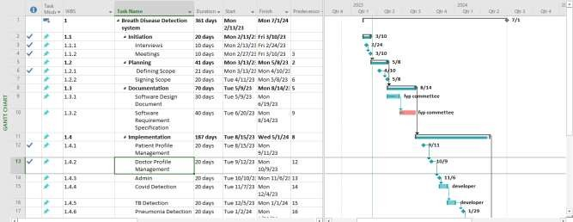

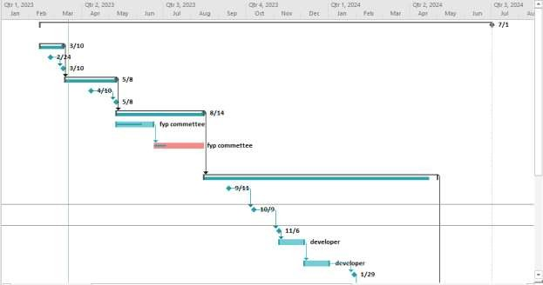

## Mockups

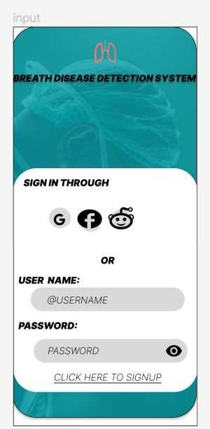

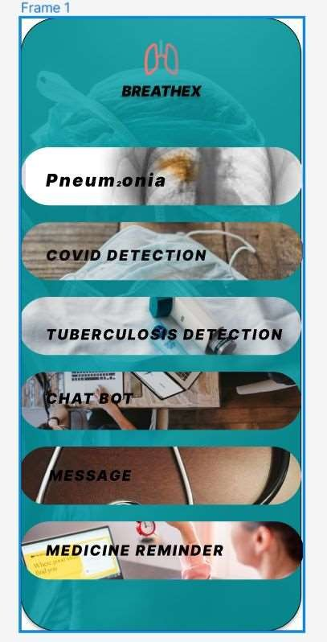

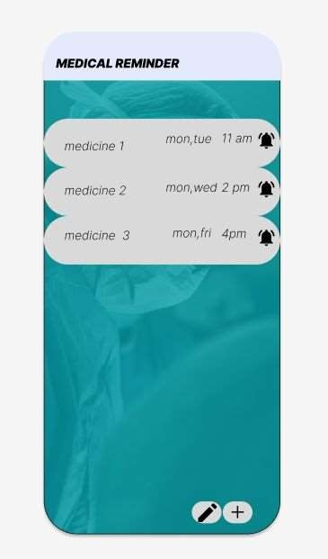

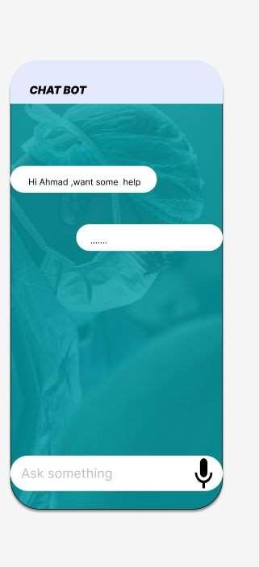

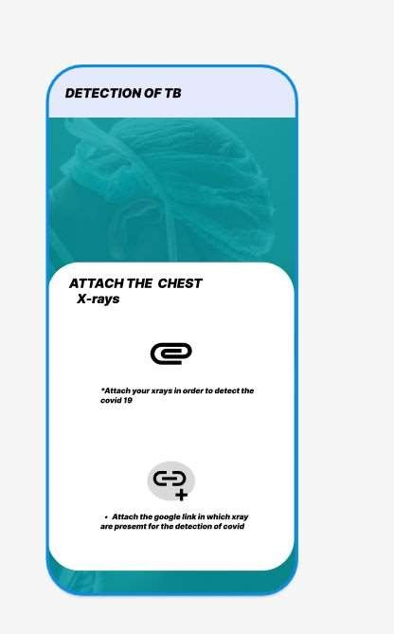

## References

I gather the information of TB,Covid-19 and pneumonia from website https://[www.woolcock.org.au/asthma-treatment-research](http://www.woolcock.org.au/asthma-treatment-research)

## Plagiarism Report

